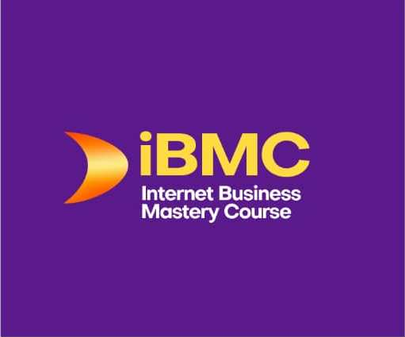
Internet Business Mastery Course
Facilitator | Paul Uduk

CONFIDENTIAL CLIENT INFORMATION FORM

THIS IS A LEGALLY BINDING FORM. DO NOT COMPLETE IF YOU DON’T WANT TO JOIN iBMC-8
Please tick or mark X or N/A if Not Applicable. All fields are mandatory
- Full name:

- Age range: 18 – 30 30 – 45 45 – 60 60 – 75 > 75

- Highest qualification: Non-graduate First degree Masters Doctorate

- Phone number:

- Private email address:

- Social Media Presence I (Mark X under the SM Platforms where you have an account)
Facebook | Instagram | YouTube | Twitter | LinkedIn | WhatsApp | Pinterest

- Social Media Presence II (Write the number of followers you have on each platform)
Facebook | Instagram | YouTube | Twitter | LinkedIn | WhatsApp | Pinterest

- Rate Your Online Business Skills On a Scale of 1 – 5 (1= Novice, 5= Expert):

- Rate Your SEO Skills On a Scale of 0 – 5 (1 = Novice, 5 = Expert):

- Do you have a website? (If yes, write your website’s URL here):

- Which Audience Management System Are You Currently Using?

- How did you hear about iBMC? (Mark x)
Email From Paul Uduk | WhatsApp Message From Paul | Other
Xx
- What are your top three goals for registering for iBMC?
a)
b)
c)

- Write down in not more than 25 words what success would look like if you’re successful.

- How do you wish to pay for the Course? (Mark X besides one of the figures)

Once  N75,000 | 2 Installments  N39,500 | 3 Installments  N27,500
*First installment on joining and the other(s) 30 days apart. If paying in dollars the fee is $227

UNDERTAKING
I undertake to put in every effort to ensure I succeed. I will do all my Lessons and Assignments timely. I will participate and be active in iBMC Groups. I understand that my success depends on me. I am willing to work hard, follow my coach’s guidance, and persevere until I achieve the goals and objective I’ve set for myself.

Signature Date

Email your completed form to pauluduk@gmail.com

Copyright ©. Paul Uduk. 2022. All rights reserved.

